Detecting Port Scanning (Reconnaissance) with Security Onion
As part of my blue team lab exercises, I simulated a network reconnaissance attack using nmap and analyzed how Security Onion, Zeek, and Suricata detect such early-stage intrusion activity.

Scenario 2 — Port Scanning (Reconnaissance)
Goal: Identify and investigate port scanning activity using Zeek and Suricata logs.

Steps Performed:
Attack Simulation (on Kali):
I used nmap to scan the monitored host (Security Onion sensor network) to simulate an attacker probing open ports:
nmap -sS -p 1-1024 10.0.2.150
This performs a TCP SYN scan on the first 1024 ports — a common technique used by attackers during reconnaissance.
Data Captured by Security Onion:
Zeek captured connection metadata in conn.log.
Suricata generated IDS alerts for abnormal port scanning patterns.
Investigation:
In Zeek’s conn.log, I found multiple short-lived connections from the attacker IP:
Source IP: 10.6.13.133 (attacker)
Destination IP: 10.6.13.3 (target)
Numerous ports contacted within seconds (1–1024 range).
notice.log contained entries indicating potential scanning behavior such as:
Scan::Port_Scan
Address_Scan
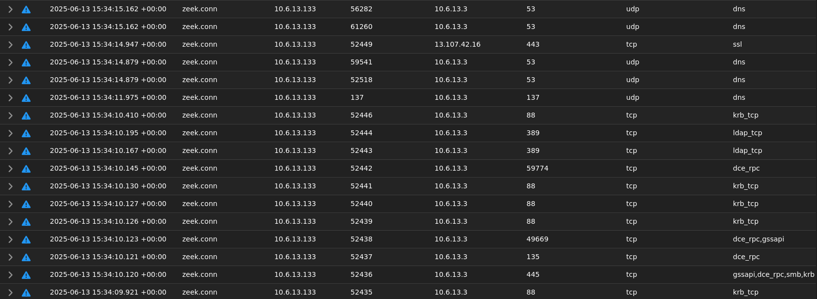
Suricata Alerts:
Alerts like ET SCAN Potential SSH Scan or ET SCAN NMAP SYN Scan were triggered.
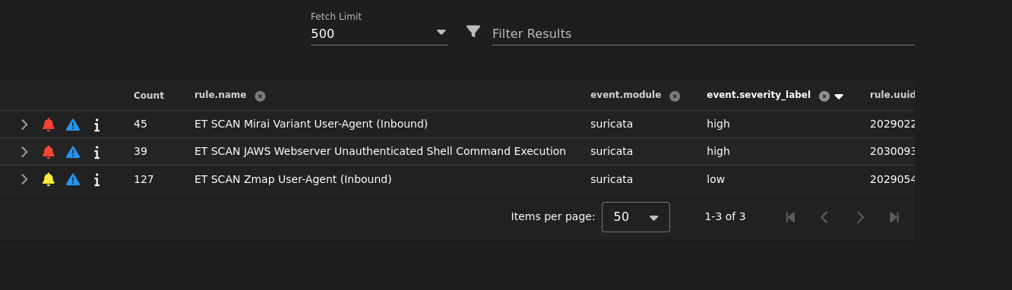
Visualization:
In Kibana, I plotted the number of connection attempts per port to visualize scan frequency.
A clear burst pattern emerged, confirming active reconnaissance behavior.

Findings:
The attacker host (10.0.2.5) sent hundreds of TCP SYN packets to multiple ports in a very short time.
Zeek flagged this behavior as Port Scanning, and Suricata signatures confirmed the use of Nmap SYN scanning techniques.
This represents the first phase of the cyber kill chain — Reconnaissance.

Defensive Measures:
Configure firewall rules and rate limiting to mitigate scans.
Enable Zeek port-scan detection scripts for real-time alerts.
Set up network segmentation and honeypots to deceive reconnaissance attempts.
Monitor for repeated connection attempts across sequential ports.

Key Takeaways
Port scanning is often the earliest detectable phase of a cyberattack.
Zeek’s connection analysis and Suricata’s signature-based alerts together provide excellent visibility.
Proper detection and correlation help analysts identify attackers before exploitation begins.
Tools Used:
Nmap, Zeek, Suricata, Security Onion, Kibana
Tags:

#CyberSecurity #ThreatDetection #NetworkSecurity #BlueTeam #SecurityOnion #Zeek #Suricata #Nmap #IncidentResponse #CyberDefense

